St Edward’s, Oxford

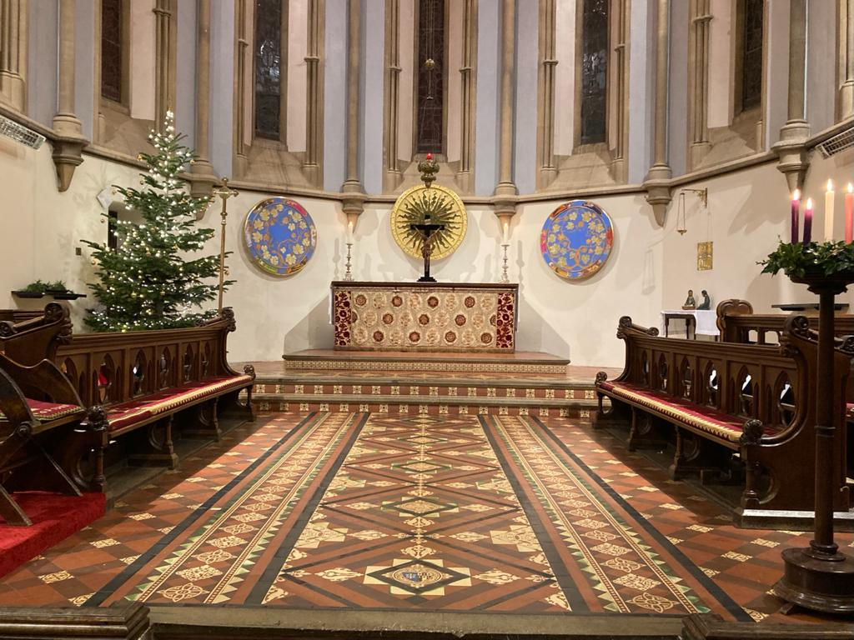

A Festival of Lessons and Carols

December 2020

WELCOME

Welcome to this special service recorded at St Edward’s School.

We are delighted that you can celebrate Christmas with us wherever you are watching. We hope you will enjoy the marvellous readings and wonderful music. As we ponder these familiar mysteries, may our worship of the little child in Bethlehem bring new hope to us all.

ORGAN MUSIC BEFORE THE SERVICE

Chorale Prelude on Nun komm, der Heiden Heiland
Johann Sebastian Bach (1685-1750) BWV 599

ORDER OF SERVICE

HYMN - O Come, O Come Emmanuel

Soloist: Harry Trowbridge, Field House

O come, O come Emmanuel!
Redeem thy people Israel,
That into exile drear is gone
Far from the face of God’s dear Son.

Rejoice, rejoice! Emmanuel
Shall come to thee, O Israel.

O come, thou Branch of Jesse! draw
The quarry from the lion’s claw;
From the dread caverns of the grave,
From nether hell, thy people save.

O come, O come, thou Dayspring bright!
Pour on our souls thy healing light;
Dispel the long night’s ling’ring gloom,
And pierce the shadows of the tomb.

O come, O come, Adonaï,
Who in thy glorious majesty
From that high mountain clothed in awe
Gavest thy folk the elder law.

Words: 18th Century, tr. Thomas Lacey (1853-1931)
Music: 15th Century French melody, arr. David Willcocks (1919-2015)

THE BIDDING PRAYER
The Chaplain

Beloved in Christ, be it this Christmastide our care and delight to hear again the message of the angels, and in heart and mind to go even unto Bethlehem and see this thing which is come to pass, and the babe lying in a manger. Therefore let us read and mark in Holy Scripture the tale of the loving purposes of God. But first, let us pray for the needs of the whole world: for peace on earth, goodwill among all his people, and unity within the Church he came to build. And because this of all things would rejoice his heart, let us remember, in his name, the poor and helpless, the cold, the hungry, and the oppressed; the sick and them that mourn, the lonely and the unloved, the aged and the little children. And let us remember before God all those who rejoice with us, but upon another shore, and in a greater light, and with whom in Christ we are for ever one. These prayers and praises let us humbly offer up, in the words which Christ himself hath taught us:
Our Father which art in heaven,
Hallowed be thy name,
Thy kingdom come,
Thy will be done,
in earth as it is in heaven.
Give us this day our daily bread;
And forgive us our trespasses,
As we forgive them that trespass against us;
And lead us not into temptation,
But deliver us from evil.
For thine is the kingdom, the power, and the glory,
For ever and ever. Amen.

The almighty God bless us with his grace; Christ give us the joys of everlasting life; and unto the fellowship of the citizens above may the King of angels bring us all. Amen.

THE FIRST LESSON

George Bradshaw, Segar’s

The prophet foretells the coming of the Saviour.
The people that walked in darkness have seen a great light: they that dwell in the land of the shadow of death, upon them hath the light shined… For unto us a child is born, unto us a son is given: and the government shall be upon his shoulder: and his name shall be called Wonderful, Counsellor, The mighty God, The everlasting Father, The Prince of Peace. Of the increase of his government and peace there shall be no end, upon the throne of David, and upon his kingdom, to order it, and to establish it with judgment and with justice from henceforth even for ever. The zeal of the Lord of hosts will perform this.

Thanks be to God.
ISAIAH 9.2, 6–7

Coventry Carol
Choir 1

Lully, lulla, lullay,
thow little tine child;
by by, lully, lullay.

O sisters too, how may we do,
For to preserve this day,
This pore yongling for whom we do singe:

Herod, the king, in his raging,
Chargid he hath this day
His men of might in his owne sight
All yonge children to slay:

That wo is me, pore child, for thee,
And ever morne and may
For thi parting nether say nor singe:

Lully, lulla, lullay;
by by, lully, lullay.

Words: Anon. 16th Century
Music: Lawrence Tao (b. 1987)

CAROL - Nun lob’, mein’ seel’, den herren

Choirs 3, 4, 5, 6 and 7 with the Gabrieli Consort

My soul, now praise your Maker!
Let all within me bless His name,
Who makes you full partaker of mercies
more than you dare claim.
Forget Him not whose meekness
still bears with all your sin,
Who heals your ev’ry weakness,
renews your life within;
Whose grace and care are endless
and saved you through the past;
Who leaves no suff’rer friendless
but rights the wronged at last.

Words: Johann Gramann (1487-1541) tr. Catherine Winkworth (1827-1878)
Music: Johann Sebastian Bach BWV 167

THE SECOND LESSON

Linda Raabe-Marjot, Head of German

The angel Gabriel salutes the Blessed Virgin Mary.
And in the sixth month the angel Gabriel was sent from God unto a city of Galilee, named Nazareth, To a virgin espoused to a man whose name was Joseph, of the house of David; and the virgin's name was Mary.
And the angel came in unto her, and said, Hail, thou that art highly favoured, the Lord is with thee: blessed art thou among women. And when she saw him, she was troubled at his saying, and cast in her mind what manner of salutation this should be. And the angel said unto her, Fear not, Mary: for thou hast found favour with God. And, behold, thou shalt conceive in thy womb, and bring forth a son, and shalt call his name Jesus. He shall be great, and shall be called the Son of the Highest: and the Lord God shall give unto him the throne of his father David: And he shall reign over the house of Jacob for ever; and of his kingdom there shall be no end.
Then said Mary unto the angel, How shall this be, seeing I know not a man?
And the angel answered and said unto her, The Holy Ghost shall come upon thee, and the power of the Highest shall overshadow thee: therefore also that holy thing which shall be born of thee shall be called the Son of God. And, behold, thy cousin Elisabeth, she hath also conceived a son in her old age: and this is the sixth month with her, who was called barren. For with God nothing shall be impossible. And Mary said, Behold the handmaid of the Lord; be it unto me according to thy word. And the angel departed from her.

Thanks be to God.
LUKE 1.26–35, 38

CAROL - Joseph, lieber Joseph mein

Choirs 1 and 2

Joseph, lieber Joseph mein,
hilf mir wiegen das Kindelein,
Gott der wird dein Lohner sein,
im Himmelreich der Jungfrau
Kind Maria.
Eya.

Virgo Deum genuit,
quem divina voluit clementia.

Omnes nunc concinite,
Nato regi psallite,
voce pia dicite:
sit Gloria Christo nato infantulo.

Hodie apparuit in Israel,
quem praedixit Gabriel,
est natus rex.
Joseph, my dear Joseph,
Help me rock the little child.
God will recompense you
in heaven, the Virgin Mary’s child.

Hey!

The Virgin has given birth to God
Whom the divine mercy willed.

Now let all sing together,
Sing to the newborn king,
Saying with devout voice:
“Glory be to Christ our babe!”

Today the one whom Gabriel predicted has appeared in Israel, has been born King.

Words: Anon. 14th Century
Music: Hieronymus Praetorius (1560-1629)

HYMN - O little town of Bethlehem

Choirs 5, 6 and 7

O little town of Bethlehem,
How still we see thee lie!
Above thy deep and dreamless sleep
The silent stars go by.
Yet in the dark streets shineth
The everlasting light;
The hopes and fears of all the years
Are met in thee tonight.

How silently, how silently,
The wondrous gift is given!
So God imparts to human hearts
The blessings of his heaven.
No ear may hear his coming;
But in this world of sin,
Where meek souls will receive him, still
The dear Christ enters in.

O holy Child of Bethlehem,
Descend to us we pray;
Cast out our sin, and enter in,
Be born in us today.
We hear the Christmas angels
The great glad tidings tell:
O come to us, abide with us,
Our Lord Emmanuel.

Words: Phillips Brooks (1835-1893)
Music: English trad. arr. Ralph Vaughan Williams (1872-1958)
Descant: Thomas Armstrong (1898-1994)

THE THIRD LESSON

Ayesha Nurjahan, Corfe

St Luke tells of the birth of Jesus.
And it came to pass in those days, that there went out a decree from Caesar Augustus that all the world should be taxed. (And this taxing was first made when Cyrenius was governor of Syria.) And all went to be taxed, every one into his own city. And Joseph also went up from Galilee, out of the city of Nazareth, into Judaea, unto the city of David, which is called Bethlehem; (because he was of the house and lineage of David:) To be taxed with Mary his espoused wife, being great with child. And so it was, that, while they were there, the days were accomplished that she should be delivered. And she brought forth her firstborn son, and wrapped him in swaddling clothes, and laid him in a manger; because there was no room for them in the inn.

Thanks be to God.
LUKE 2.1–7

CAROL - In the bleak midwinter

Choir 3
Soloists: Flossie Butler-Adams, Mac’s and Patrick Maxwell, Cowell’s

In the bleak mid-winter,
Frosty wind made moan,
Earth stood hard as iron,
Water like a stone;
Snow had fallen, snow on snow,
Snow on snow,
In the bleak mid-winter, long ago.

Our God, heav’n cannot hold him
Nor earth sustain,
Heav’n and earth shall flee away
When He comes to reign:
In the bleak mid-winter
A stable place sufficed:
The Lord God Almighty Jesus Christ.

Enough for him, whom Cherubim
Worship night and day,
A breastful of milk,
And a manger full of hay;
Enough for him, whom Angels
Fall down before,
The ox and ass and camel, which adore.

What can I give him
Poor as I am?
If I were a shepherd
I would bring a lamb;
If I were a wise man
I would do my part,
Yet what I can I give him – give my heart.

Words: Christina Rossetti (1830-1894)
Music: Harold Darke (1888-1976)

HYMN - Once in royal David’s city

Soloist: Lara Sowande, Avenue

Once in royal David’s city
Stood a lowly cattle shed,
Where a Mother laid her baby
In a manger for his bed:
Mary was that mother mild,
Jesus Christ her little child.

He came down to earth from heaven
Who is God and Lord of all,
And his shelter was a stable,
And his cradle was a stall;
With the poor and mean and lowly
Lived on earth our Saviour holy.

And our eyes at last shall see him,
Through his own redeeming love,
For that Child so dear and gentle
Is our Lord in heaven above;
And he leads his children on
To the place where he is gone.

Not in that poor lowly stable,
With the oxen standing by,
We shall see him; but in heaven,
Set at God’s right hand on high;
When like stars his children crowned
All in white shall wait around.

Words: Cecil Francis Alexander (1818-1895)
Music: Henry Gauntlett (1805-1876), harm. Arthur Mann (1850-1929)
Descant: David Willcocks

THE FOURTH LESSON

Mr David Aldred, OSE

The shepherds go to the manger.
And there were in the same country shepherds abiding in the field, keeping watch over their flock by night. And, lo, the angel of the Lord came upon them, and the glory of the Lord shone round about them: and they were sore afraid.
And the angel said unto them, Fear not: for, behold, I bring you good tidings of great joy, which shall be to all people. For unto you is born this day in the city of David a Saviour, which is Christ the Lord. And this shall be a sign unto you; Ye shall find the babe wrapped in swaddling clothes, lying in a manger.
And suddenly there was with the angel a multitude of the heavenly host praising God, and saying, Glory to God in the highest, and on earth peace, good will toward men. And it came to pass, as the angels were gone away from them into heaven, the shepherds said one to another, Let us now go even unto Bethlehem, and see this thing which is come to pass, which the Lord hath made known unto us.
And they came with haste, and found Mary, and Joseph, and the babe lying in a manger. And when they had seen it, they made known abroad the saying which was told them concerning this child. And all they that heard it wondered at those things which were told them by the shepherds. But Mary kept all these things, and pondered them in her heart. And the shepherds returned, glorifying and praising God for all the things that they had heard and seen, as it was told unto them.

Thanks be to God.
LUKE 2.8–16

CAROL - This is the record of John

Choirs 1 and 3
Soloist: Theo Weldon, Kendall

This is the record of John,
when the Jews sent priests and Levites from Jerusalem to ask him, Who art thou?
And he confessed and denied not, and said plainly:
I am not the Christ.

And they asked him: What art thou then? Art thou Elias?
And he said, I am not.
Art thou the prophet?
And he answered, No.

Then said they unto him,
What art thou? That we may give an answer unto them that sent us.
What say’st thou of thyself?
And he said, I am the voice of him that crieth in the wilderness,
Make straight the way of the Lord.

Words: JOHN 1:19-23
Music: Orlando Gibbons (1583-1625)

THE FIFTH LESSON

The Warden

St John unfolds the great mystery of the Incarnation.
In the beginning was the Word, and the Word was with God, and the Word was God. The same was in the beginning with God. All things were made by him; and without him was not any thing made that was made. In him was life; and the life was the light of men. And the light shineth in darkness; and the darkness comprehended it not.
There was a man sent from God, whose name was John. The same came for a witness, to bear witness of the Light, that all men through him might believe. He was not that Light, but was sent to bear witness of that Light. That was the true Light, which lighteth every man that cometh into the world. He was in the world, and the world was made by him, and the world knew him not. He came unto his own, and his own received him not. But as many as received him, to them gave he power to become the sons of God, even to them that believe on his name: Which were born, not of blood, nor of the will of the flesh, nor of the will of man, but of God. And the Word was made flesh, and dwelt among us, (and we beheld his glory, the glory as of the only begotten of the Father,) full of grace and truth.

Thanks be to God.
JOHN 1.1–14

CAROL - O Holy Night

All choirs

O holy night! The stars are brightly shining,
It is the night of our dear Saviour's birth.
Long lay the world in sin and error pining,
Till He appear'd and the soul felt its worth.
A thrill of hope, the weary world rejoices,
For yonder breaks a new and glorious morn.
Fall on your knees! O hear the angel voices!
O night divine, O night when Christ was born;
Led by the light of faith serenely beaming,
With glowing hearts by His cradle we stand.
So led by light of a star sweetly gleaming,
Here come the wise men from the Orient land.
The King of Kings lay thus in lowly manger;
In all our trials born to be our friend.
He knows our need, to our weaknesses no stranger,
Behold your King! Before Him lowly bend!
Truly He taught us to love one another;
His law is love and His gospel is peace.
Chains shall He break for the slave is our brother;
And in His name all oppression shall cease.
Sweet hymns of joy in grateful chorus raise we,
Let all within us praise His holy name.
Christ is the Lord, then ever, ever praise we:
his pow’r and glory evermore proclaim!

Words: Placide Cappeau (1808-1877) tr. John Sullivan Dwight (1813-1893)
Music: Adolphe Adam (1803-1856) arr. Darius Battiwalla (b. 1966)

BLESSING
The Chaplain

May the joy of the angels,
the eagerness of the shepherds,
the perseverance of the wise men,
the obedience of Joseph and Mary,
and the peace of the Christ-child
be yours this Christmas;
and the blessing …

HYMN - O come, all ye faithful

O come, all ye faithful,
Joyful and triumphant,
O come ye, O come ye to Bethlehem;
Come and behold him,
Born the King of Angels:

O come let us adore him,
O come let us adore him,
O come let us adore him, Christ the Lord!

God of God,
Light of Light,
Lo! he abhors not the Virgin’s womb;
Very God,
Begotten not created:

Sing, choirs of Angels,
Sing in exultation,
Sing, all ye citizens of heaven above,
Glory to God
In the highest:

Words: tr. Frederick Oakeley (1802-1880)
Music: Unknown (probably 18th Century), arr. David Willcocks

ORGAN VOLUNTARY

Chorale Prelude on In dulci jubilo
Johann Sebastian Bach BWV 729

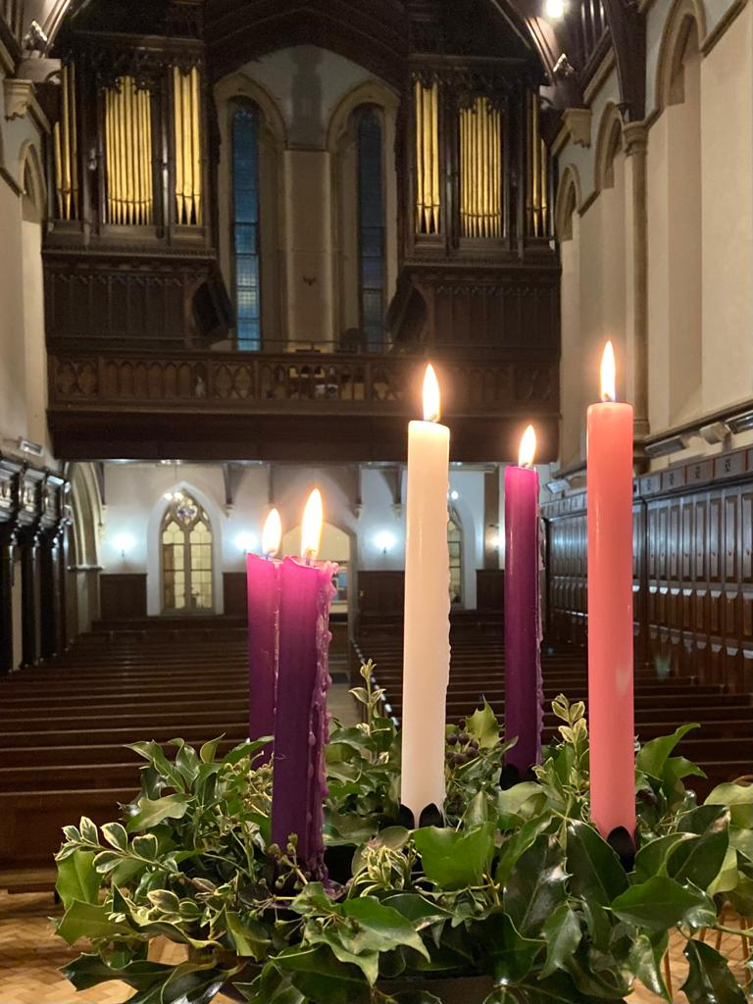

We wish you a very Happy Christmas.

