Curriculum Policy

Overview

St Edward’s, Oxford aims to provide a broad and stimulating curriculum in a fashion that challenges pupils at a level appropriate to the stage of their education.

The informing principles of curriculum planning at St Edward’s can be summarised as follows:

- To instil high academic expectations and standards;
- To equip pupils with learning skills essential to making academic progress;
- To engender in pupils a desire to seek, reflect on and use feedback so to strengthen areas of weakness and regulate learning and decision making;
- To encourage curiosity and creativity as part of a commitment to learning which will last a lifetime;
- To promote spiritual, moral, cultural, mental and physical development of pupils so that they can take their place as fully-rounded members of a tolerant society.

The learning skills and values that St Edward’s seeks to develop in pupils is summarised as:

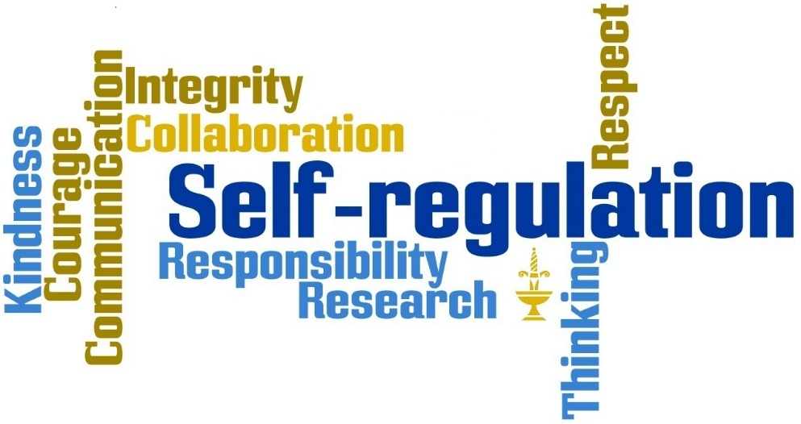

Equal opportunities and differentiation

St Edward’s is committed to making the curriculum accessible to all its pupils as far as is reasonably practical. Entry to the school is by the Common Entrance examination or our own assessment, regardless of sex, race, disability, religion or belief. Details of specific learning needs are taken into account, and all reasonable adjustment is made. One or more lessons each week are offered for those requiring specialist support either with English as an additional language, literacy or numeracy. No separate charge is made for Learning Development or EAL lessons. Further details can be found in the Learning Development Policy.

Considerable emphasis is placed on engaging and collaborative pedagogy with the acknowledgement that pupils who are motivated by the teachers and peers will enjoy progression. It is held that pupils with the appropriate mind-set can be coached to take ownership of overcoming specific challenges. As such the school holds the view that each pupil has specific needs (whether formally identified or otherwise) and that the role of teachers and tutors is to provide guidance on possible actions that could be used by any pupil for academic or personal progression. A wide range of academic societies and workshops are on offer to all pupils to enrich, extend and support wider learning.

Learning outside the classroom

Learning activities outside the classroom are important to developing self-regulated learners. As pupils go through the school the expectation to work being completed in time additional to that formally allocated increases. Formal prep time equates to 2 hours each day. Work set by teachers will not always fit into this time, and pupils will need to find time to work outside supervised prep periods. In the Sixth Form pupils are expected to spend as much time studying independently as they do in the classroom (20hrs + 20hrs per week). Time is available through structured prep, timetabled study periods, and other periods of free time which will vary from pupil to pupil. Senior pupils are encouraged to embrace reading lists provided by departments.

Tutors as Coaches (making use of information)

The school adopts a coaching approach to developing pupils (this is mirrored by the staff professional development process) where the assumption is made that pupils are aware of the decisions that are available to them when faced with challenge, even if the routes actually chosen are not always desirable. A tutor uses information provided by pupil’s teachers to guide coaching conversations and assist in improving decision making inside and outside the classroom so to make progress. A key aim is to provide pupils with a sense of ownership for the outcomes.

The reporting and reward/sanction systems provide the main sources of information to Tutors. Teachers are further encouraged to engage in conversation with tutors directly to aid the process. Heads of Years and the Deputy Head Academic have oversight for monitoring and tracking the progression of pupils in the context of their respective year groups and ability profiles. The Head of Learning Development oversees tracking for pupils recognised on the SEND register.

Blue Flags are recorded by teachers on the school information management system (3 SYS) to celebrate when a pupil demonstrates progression in regard to learning skills. A pupil can be asked to show an individual piece of good work to the Warden (at 8.20 a.m. on a Monday or Friday).

Red flags are recorded by teachers as a guide to help pupils engage in improving learning skills or when a pupil has affected negatively on their own learning or that of others.
Curriculum by year
Shell year (Year 9)

Pupils study a core curriculum of 17 subjects. This includes two foreign languages from French, German, Ancient Greek and Spanish which can be studied either ab initio or with prior experience. EAL lessons may take the place of one of these languages as appropriate. Pupils also choose between Latin and Classical Studies. Outside the timetable the curriculum includes a circus of activities delivered partly within the timetable and partly through a free-standing programme of activities. Pupils are taught in forms for all subjects other than Mathematics and Languages, where they are placed in sets.

Subjects taught within the timetable: Art, Biology, Chemistry, Classical Studies, Design & Technology, Drama, English, French, Geography, German, Greek, History, Latin, Mathematics, Music, Physics, Physical Education, PSHE, Religious Education, Spanish.

Fourth and Fifth Form (Years 10 & 11)

In April of the Shell year pupils make a choice of five optional subjects to study to GCSE, one of which must be a non-native language. Exceptionally, a case is made for a pupil to study only four of the possible optional subjects, where it is felt that additional space for learning or additional language development is more valuable. All GCSE subjects are taken during the Fifth Form. Able mathematicians also take Additional Maths. All Fifth Form pupils complete a Personal Psychometric Assessment (PPA) to support the initial stages of the careers process and Sixth Form choices. Individual careers meetings are held through the Autumn term of the Fifth Form supported by targeted career events with specific and relevant industry leaders.

A programme of sports and activities continues outside timetabled lessons throughout the Fourth and Fifth Forms. PSHE is delivered within timetabled sessions throughout the two years. Pupils in the Fourth Form engage in wider enrichment through lessons incorporating Religious Education, Ethics and Political Literacy.

During the Fourth Form pupils undertake a piece of work independently on a topic and in a form of their choosing. The work culminates in a presentation evening where pupils are interviewed by outside assessors about the process of self-directed study. The so called Warden’s Project is pivotal to the middle school curriculum and draws attention to the pupil centred approach taken by the school and the need for young people to develop skills of self-regulation. It further represents an opportunity for teachers to coach pupils.

Core Subjects:

English (Language and/or Literature), Mathematics, Biology, Chemistry and Physics (to Double or Triple Award). One modern foreign language is taken as one of the optional subjects.

Optional GCSE subjects:

Art  Ceramics  Classical Civilisations  Design & Technology  Drama | French  Geography  German  Greek  History | Latin  Music  Physical Education  Religious Studies  Spanish
Sixth Form (Years 12 and 13)

Pupils in the Fifth Form proceed to Sixth Form provided that they pass a minimum of six GCSEs at grade B or above, with at least an A in any subject they wish to study in the Sixth Form at HL or A Level. Pupils desiring entry to the school at Sixth Form undertake entrance exams and interviews.

There are two programmes of study open to pupils entering the Sixth Form: A level and the International Baccalaureate Diploma Programme. PSHE continues and includes training for all pupils on being prefects. Careers and Higher Education advice continues and is intrinsic to the tutorial programme. All pupils receive further one to one interviews with the head of careers. This is supported by an extensive programme of outside speakers.

A level

Pupils choose 3 subjects from the list below, 4 when Greek or further Maths is chosen. All pupils also complete the Extended Project Qualification (EPQ). This is accompanied by a taught skills and learning theory course.

Art  Biology  Chemistry  Classical Civilisation  Design & Technology  Economics  English Literature  French | Further Mathematics  Geography  German  Greek  History  History of Art  Latin  Mathematics | Music  Physical Education  Physics  Politics  Religious Studies  Spanish  Theatre Studies
International Baccalaureate Diploma Programme

Pupils chose one subject from each of the six groups. Three subjects are studied at Higher Level, three at Standard Level. Pupils may choose to take an additional Science, Humanity or Language in the place of Group 6. All pupils also complete an extended essay and a course on the Theory of Knowledge as two elements of the Core programme. A programme of Creativity, Action and Service activities completes the Core.

Group | Area | HL or SL | SL only
1 | Language & Literature (native) | English (Literature)
2 | Languages Acquisition (non-native) | French German Spanish Latin  Classical Greek | Italian (ab initio)  Spanish (ab initio)  German (ab initio)
3 | Individuals & Societies | Economics Geography History Philosophy Global Politics  Psychology | Environmental Systems & Societies  World Religions  History of Art
4 | Sciences | Biology Design  Chemistry Physics  Sports Exercise & Health | Environmental Systems & Societies  Science  Astronomy
5 | Mathematics | Maths | Maths Studies
6 | Arts | Music Theatre Arts Visual Arts

In rare cases, owing to timetable constraints, pupils may not be able to their ideal subject combination.

Structure of teaching

The school operates a two-week timetable cycle based around 55 minute lessons. A level Sixth Form courses are taught in 12 lessons per cycle; IB Higher Level in 8 lessons per cycle and IB Standard Level in 6 lessons per cycle. Lower Sixth A level pupils benefit also from a course covering learning skills and theory - 4 lessons per cycle. Lower Sixth IB pupils benefit from a CAS course – 3 lessons per cycle. The balance of learning in the Lower School is as follows:

Shells no. of lessons 4th Form no. of lessons 5th Form no. of lessons

English 6 English 6 English 6
Maths 6 Maths 6 Maths 6
Sciences 9 Sciences 15 Sciences 15
MFL 4 Block f 5 Block f 5
Classics 4 Block g 5 Block g 5
2nd language 4 Block h 5 Block h 5
Geography 3 Block j 5 Block j 5
History 3 Block k 5 Block k 5
PE 2 *Non-examined 3 PSHE 1
Music 2 PSHE 1 Private Study 3
Art 2 56 56
RS/PSHE 3
Design 2
Drama 2
Sport 4
56

*This course rotates between Political Literacy, Religious Studies and Warden’s Project

